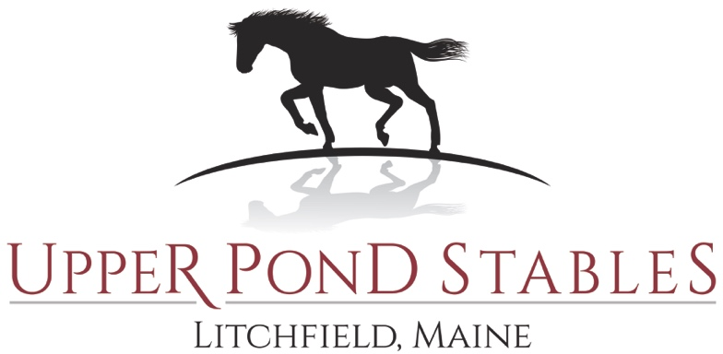
Saturday, October 15, 2022 at 9:00 a.m. - 147 Upper Pond Road, Litchfield, Maine

JUDGE: JESS SMALL
ENTRY INFORMATION:
ENTRY FEES: • All Fees must be paid in full prior to issuing a number.
$10.00 office fee per horse – Must be paid with entry

$10.00 Fee Per Class - MUST BE POST MARKED NOT LATER THAN OCTOBER 12, 2022 OR RECEIVED IN HAND AT THE BARN NO LATER THAN OCTOBER 14, 2022

$12.00 Fee Per Class - DAY OF THE EVENT
- Entries must be made in writing, signed by the owner, and must be accompanied by funds to cover all charges. If the owner or exhibitor is under 18 years of age, the entry blank must be signed by an adult who assumes all responsibilities and risks stated on the entry blank. Payment will also constitute responsibility for said minor.
- Proof of Negative Coggins within the last three years is required for horses stabled in the State of Maine. Please include copy of Coggins with your entry blank.
- Vaccinations. All animals on the grounds be vaccinated for RABIES within one year from this show. Other vaccinations are also encouraged: Please include a copy of vaccination records for your horse(s) with your entries.
** CASUAL OR SHOW ATTIRE** Six ribbons will be awarded in all classes

Upper Pond stables
Litchfield, Maine
Tina M. Titus, Owner
(207) 841-9922
Website: Upperpondstable.com
Email: tina@upperpondstable.com

