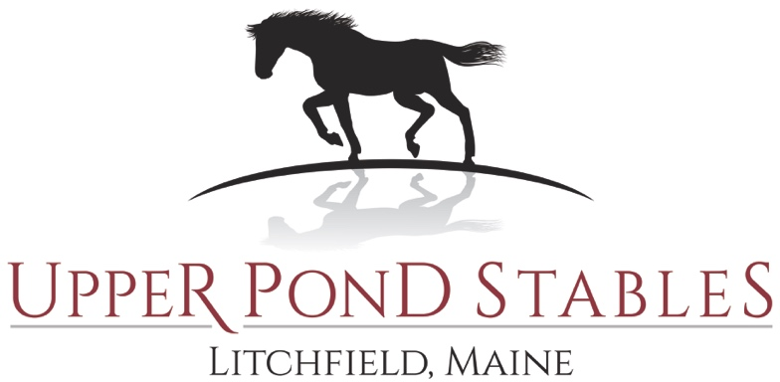
OCTOBER 15, 2022 – 9:00 A.M. - FUN SHOW
Rider name:______________________________________________Age:____________
Horse Name:_________________________________________________________
Owner/Contact Information:_____________________________________________
Phone number: _______________________________________________________
E-mail Address:_______________________________________________________
CIRCLE ALL CLASSES YOU ARE ENTERING: **MUST include $10.00 office fee**

$10.00 per class if received prior to 10/12/2022 - $12.00 per class day of event
Payment must accompany entry form Payable to: Upper Pond Stables - Mailing address: 147 Upper Pond Road, Litchfield, ME 04350 – ANY CHECKS RETURNED FOR NSF SHALL BE CHARGED an additional $50.00.
1 | 2 | 3 | 4 | 5 | 6 | 7 | 8 | 9 | 10
11 | 12 | 13 | 14 | 15 | 16 | 17 | 18 | 19 | 20
21 | 22 | 24 | 25 | 26
TOTAL DUE:
TOTAL FOR CLASSES: ____________
OFFICE FEE: $10.00
CLASS DAY FEE: $100.00 (does NOT include office fee)
TOTAL PAID: ________________

If you are riding in friends and family – name of second rider: ___________________________________

SIGNATURE REQUIRED ON NEXT PAGE
Every entry at this event shall constitute an agreement that the person making it, owner, lessee, trainer, manager, agent, coach, parent or guardian and the horse, shall be subject to the rules and regulations of the show, and that every horse/rider is eligible as entered and that the owner and any of his or her representatives are bound by the rules of the show, accept as final the decision of the show management thereof on any question arising under horse or pony said rules and agree to hold the show and management of Upper Pond Stables, Inc., RoanStar Holdings, LLC and officials and employees, harmless for any action taken. The show and equine rules are governed by the Laws of the State of Maine. All exhibitors agree that, the staff, owner of Upper Pond Stables , Inc. and RoanStar Holdings, LLC and officials of this show are to be held harmless for all events and issues resulting from or associated with the use of the premises. These events or issues include, but are not limited to, the cost of loss, damage, accidents or legal expenses. (If the exhibitor is a minor, a parent/guardian must sign the entry form.)
WARNING Under Maine Law an equine professional has limited liability for an injury or death resulting from the inherent risks of equine activities
Owner or Rider Signature:__________________________________________________________________
Minor’s Name & Parent/Guardian Signature: _________________________________________________________________________________________

